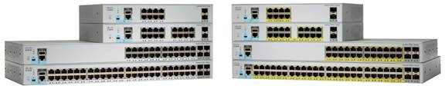

Cisco Catalyst® 2960-L Series Switches are fixed-configuration, Gigabit Ethernet switches that provide entry-level enterprise-class Layer 2 access for branch offices, conventional workspaces, and out-of-wiring closet applications. Designed for operational simplicity to lower total cost of ownership, they enable secure, and energy-efficient business operations with a range of Cisco IOS® Software features.
“These L-series switches power small networks with quietness and simplicity. They can be appropriately targeted in bank branches, hotel buildings, school buildings, retail stores, office buildings, etc as it meets the specifications that are often demanded in these scenarios. These switches are low-priced GE model, with simple management, low energy consumption, small factor plugin support, Basic layer 2 functionalities and other enterprise grade quality features that is often needed in the above sectors.”
“The below L-series switches portfolio highlights the available switches in 8,16,24 and 48 ports also showing the SFP uplinks, fanless configuration and other technicalities.”

